1. WAP to swap two variables using with and without a temp variable.
2. Find factorial.
3. If a number is prime or not.
4. Display first *n* prime numbers.
5. HCF of two numbers
6. LCM of two numbers
7. Fibonacci series of n numbers
8. Add digits of an integer.
9. Learn recursion from the lab instructor and implement (a) factorial of a number (b) Fibonacci series (c) Summation of n
10. Consider a staircase with 'n' no. of steps. Write a code to find the no. of ways you can climb the staircase, if maximum allowed step is equal to 3 steps.
11. Tower of Hanoi.

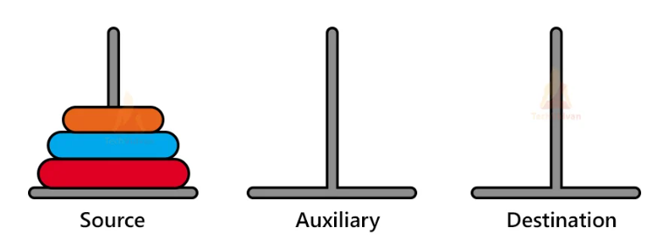

1. Consider a maze path of n rows and b columns. A person is standing at the coordinate (1,1) as shown in example maze given below. Find the number of ways he can use to reach rightmost corner of the bottom column. He can only move right and down and can take only single steps.

